**PRACTICAL-6**

Part1: JK Enterprises have set up their organization tree. User Alice Smith gets married and decides to take her husband’s surname (Smyth). She uses ISIM to modify her personal information to reflect the change. Due to management restructuring, Alice Smyth now will report to Sue Thomas. Also, management wants to transfer Sue Thomas to the Finance unit, Bob Smith to the World Wide location in Sales and John Davis to the TechSupport business partner organization.

***Functional model***

The functional model is the LDAP protocol itself. This protocol provides the means for accessing the data in the directory tree. Access is implemented by authentication operations (bindings), query operations (searches and reads), and update operations (writes).

1. Changing user information
   1. Changing a name
      1. On the Home tab, go to Manage Users.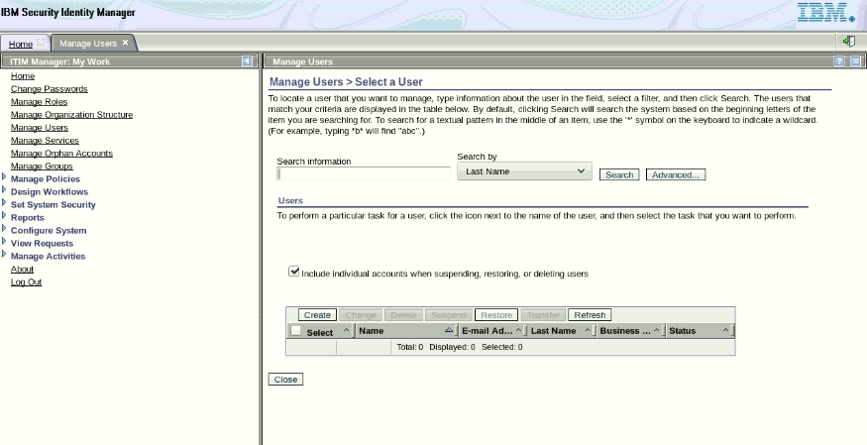
      2. Click Refresh. Locate Alice Smith. Click the arrow to the right of the name and click Change.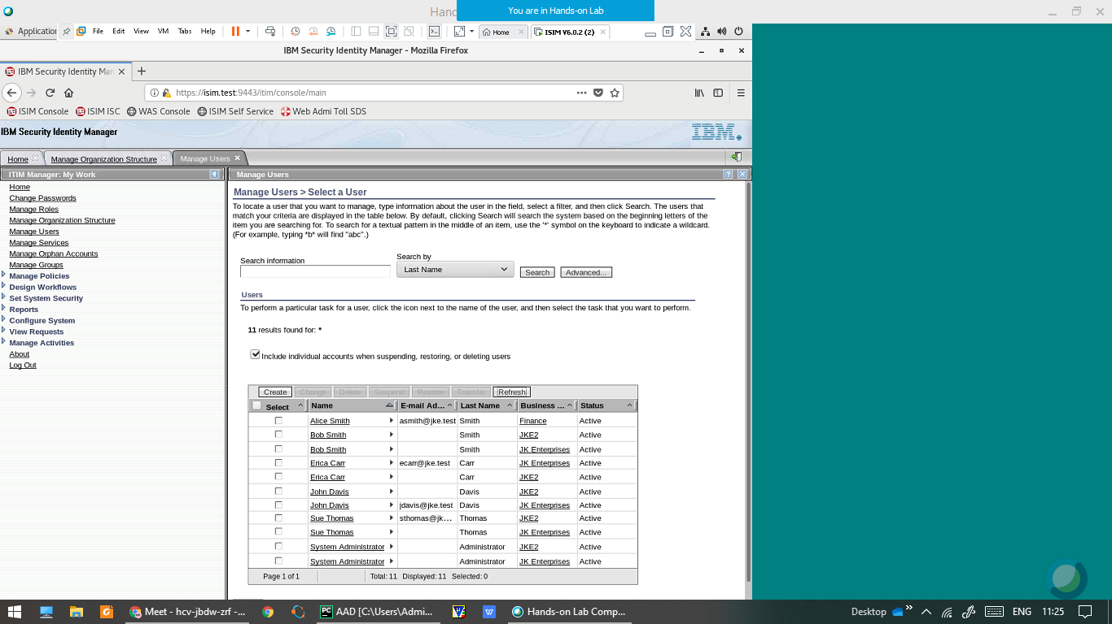
      3. Change the Last name, Full name, Preferred user ID, and email address attributes to reflect her married name, Smyth. Click Submit Now to send the update.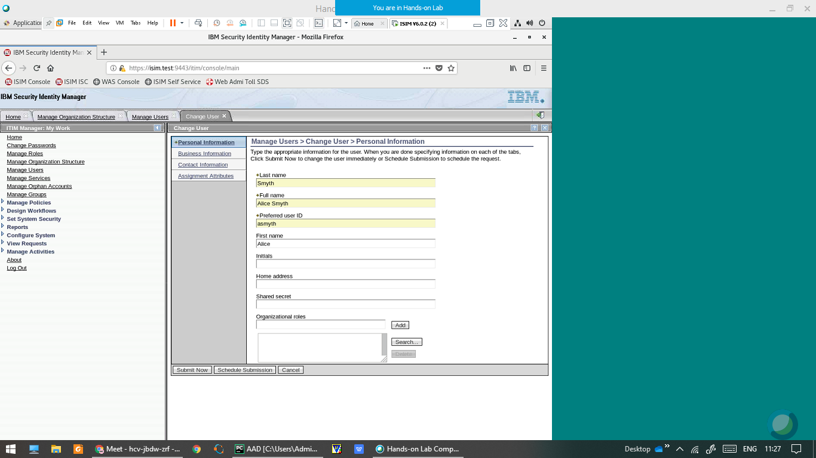
      4. Refresh the user list to confirm the name change.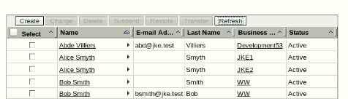
      5. Click the arrow to the right of Alice Smyth and click Accounts. Click Refresh. For the account on ITIM Service, Click arrow to the right and Click Change and change the user id from asmith to asmyth and Submit the request. Click Refresh to confirm changes.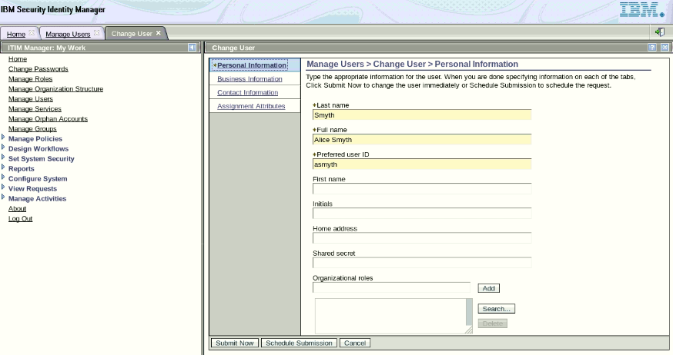
   2. Changing a manager attribute
      1. On the Home tab, you go to Manage Users.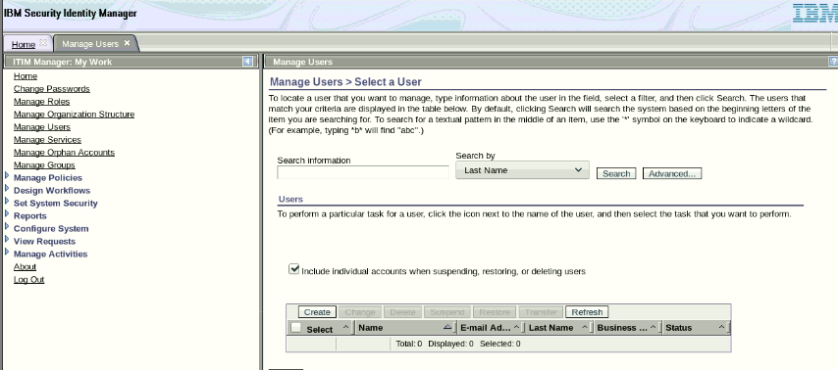
      2. Locate Alice Smyth. Click the arrow to the right of the name and click Change.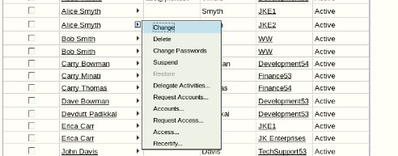
      3. Click the Business Information tab.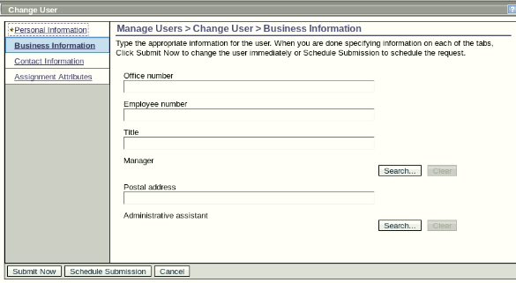
      4. In the Manager field, click Search and locate Sue Thomas. Select Sue as the manager and Click OK.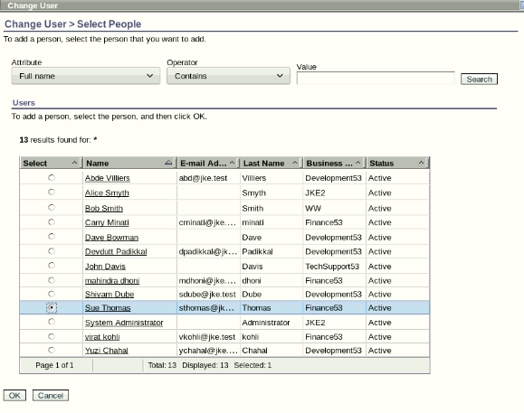
      5. Click Submit Now to update the entry. Click Close.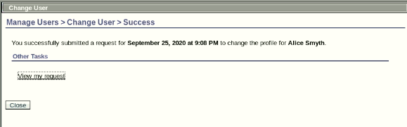

1. Transferring users
   1. On the Home tab, go to Manage Users.
   2. Search the user list and locate the entry for Sue Thomas.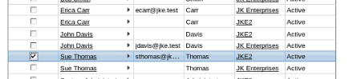
   3. Select the Sue Thomas entry and click Transfer.Search for the Finance organizational unit. Select Finance and click OK.(Finance53 was previously named finance)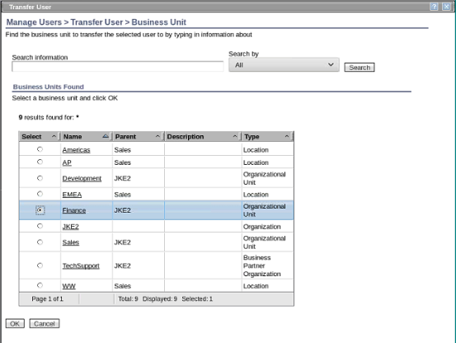
   4. Click Transfer. Click Close.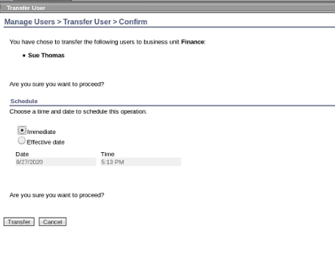
   5. Return to the Manage Users tab. Refresh the user list to verify that Sue Thomas is transferred.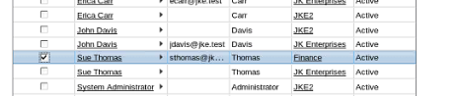
   6. Repeat steps 1 through 6 to transfer Bob Smith to the WW location in Sales. Also, transfer John Davis to the TechSupport business partner organization.(Previously without adding suffix 53)

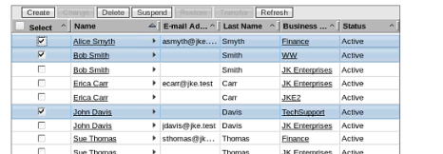

Part2: JK Enterprises wants to create static organizational roles for the various functions in the finance department and dynamic organizational roles for the Help Desk function for TechSupport. Child role assignment is also created for finance roles. An enterprise also wants to ensure that they adhere to the best practices of separation of duty in their finance department and approving a separation of duty policy violation.

1. Creating organizational roles
   1. Creating static organizational roles
      1. On the Home tab, click Manage Roles.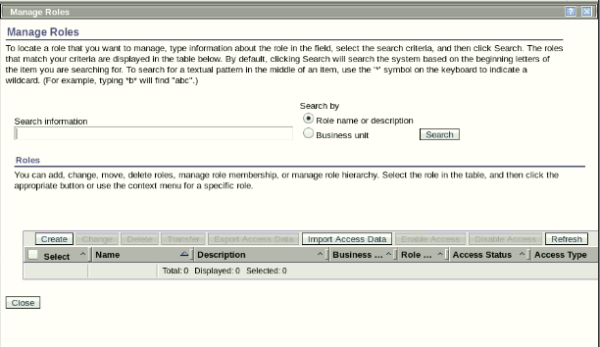
      2. Click Create to add a new role.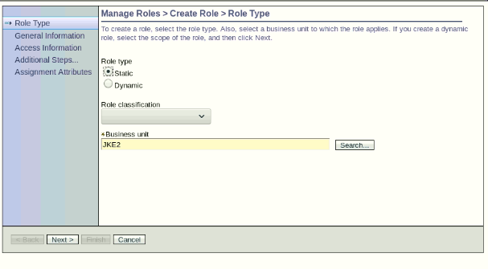
      3. Complete the Create Role form with the following information:( Business unit:JKE2)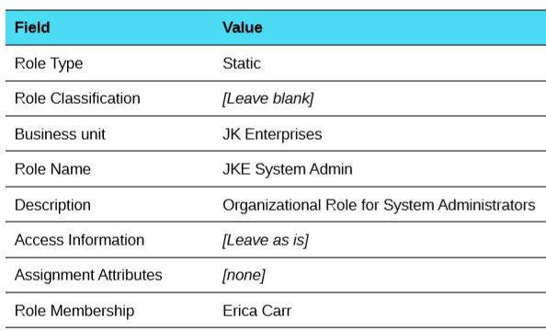
      4. Click Finish. Click Return to the list of Roles I was working with
         1. System Account Owner with a Business unit of JKE2
         2. Finance Employees with the Business unit of Finance53.
         3. Asset Handling and Disposition with the Business unit of Finance53.
            1. Check the Enable access for this role check box. Also,check the Show this role as a common access check box. These settings allow users to request membership in the roles as an access.
         4. Booking and Ledgers with the Business unit of Finance53.
            1. Check the Enable access for this role checkbox. Also,check the Show this role as a common access check box.
         5. Comparison and Review with the Business unit of Finance53.
            1. Check the Enable access for this role check box. Also,check the Show this role as a common access check box.

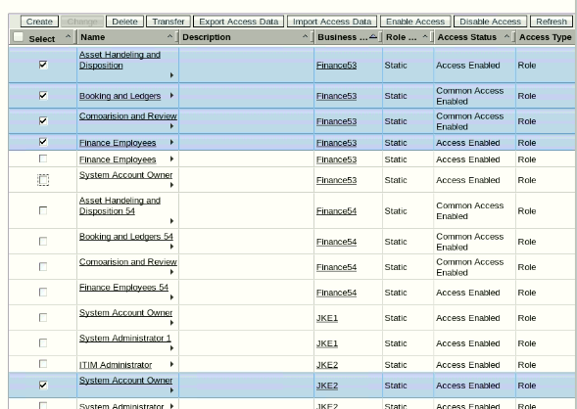

* 1. Creating Dynamic organizational roles
     1. Choose the Dynamic role type.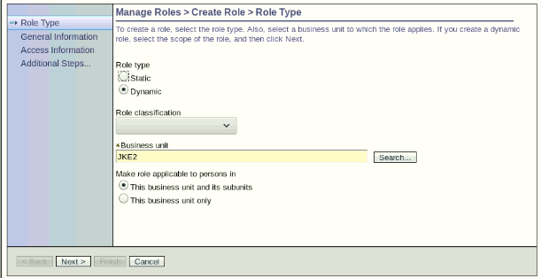
     2. Complete the Create Role form with the following information: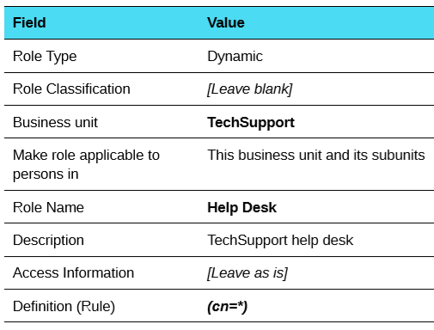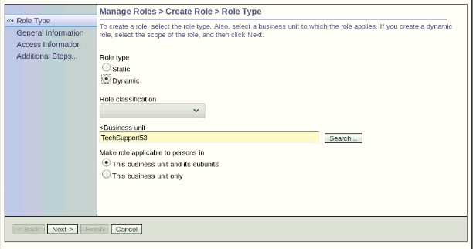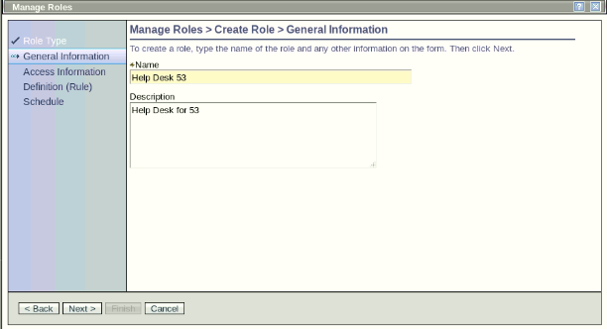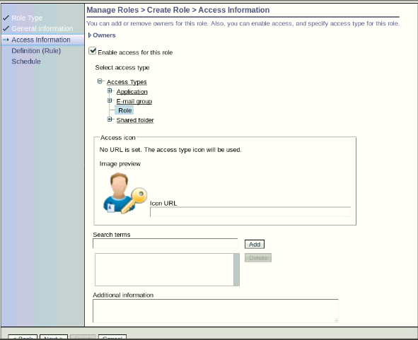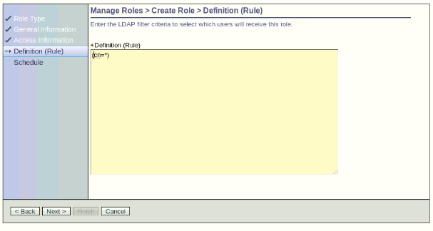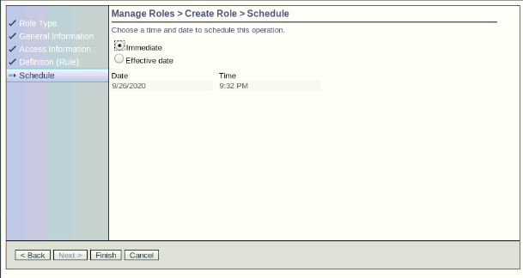
     3. Click Finish.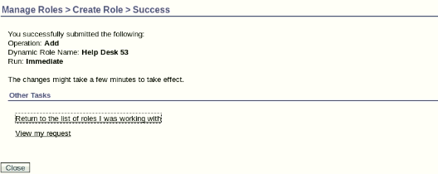

1. Creating child role assignments
   1. On the Home tab, click Manage Roles.
   2. In the Search Information box, type Finance* to find the role created. Click Search. The result should be a list that contains the Finance Employees role.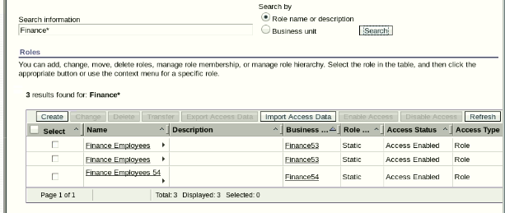
   3. Click the arrow to the right of Finance Employees and select Add Child Roles.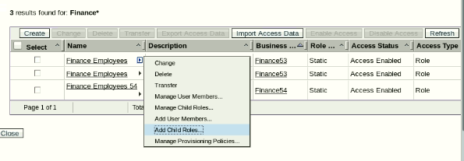
   4. Search for all the roles in the business unit of Finance53.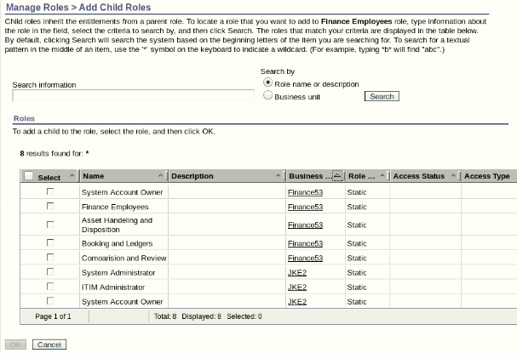
   5. Select the three finance child roles:
      1. Asset Handling and Disposition
      2. Booking and Ledgers
      3. Comparison and Review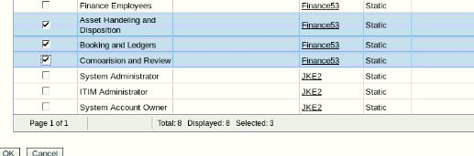
   6. Click OK .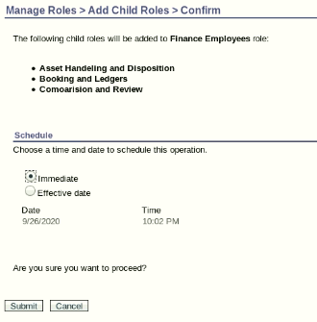
   7. Select the Immediate radio button and click Submit.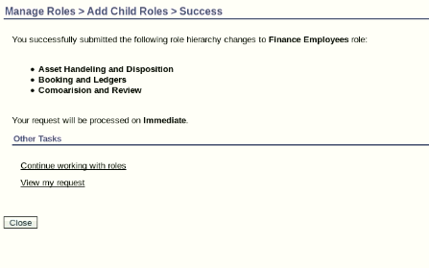

1. Creating a separation of duty policy
   1. On the Home tab, go to Manage Policies > Manage Separation of Duty Policies.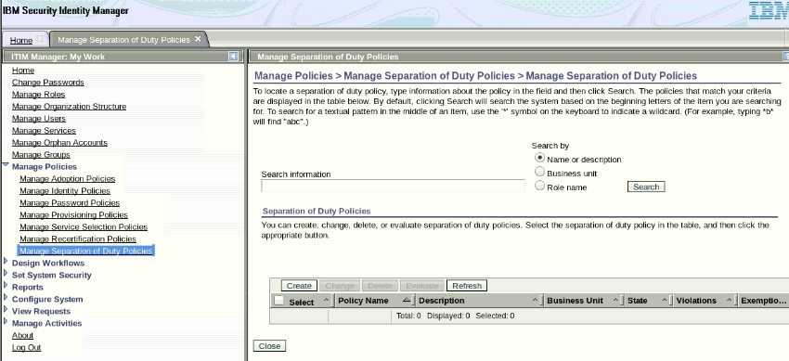
   2. Click Create.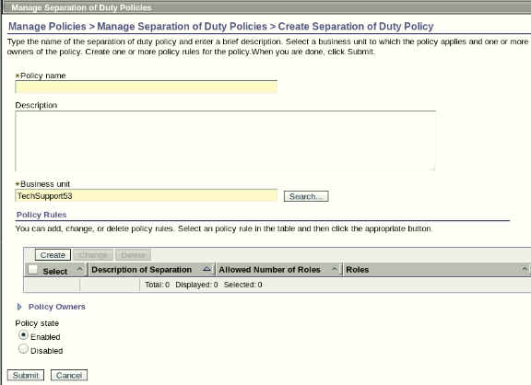
   3. Create the policy with the following information: (Business Unit :Finance53)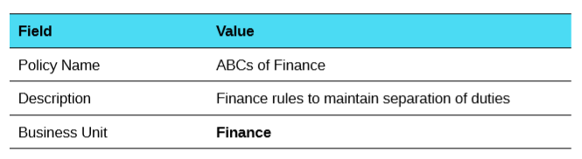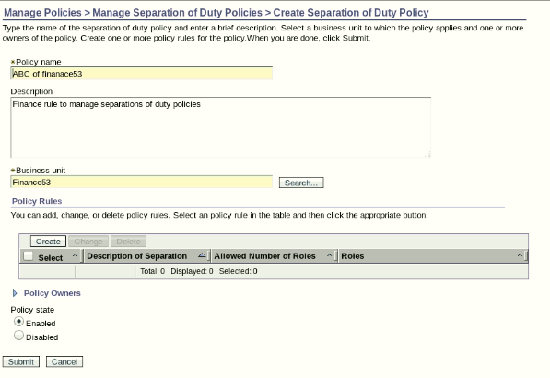
   4. In the Policy Rules section, click Create to create a policy rule with the following information: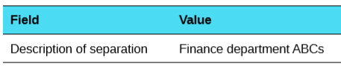
   5. Click Search in the Build Role Separation List section.
      1. Search for roles in the business unit of Finance:
         1. Asset Handling and Disposition
         2. Booking and Ledgers
         3. Comparison and Review
      2. After selecting the three roles, select the number of allowed roles. In this case, allow only one role.Click OK.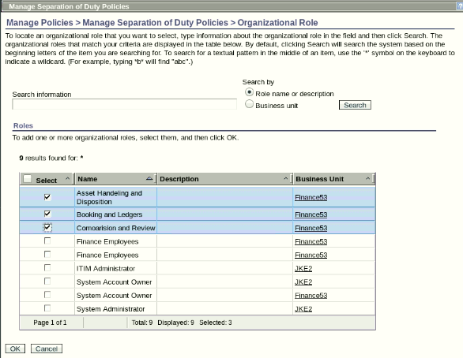
   6. Under Policy Owners > User Policy Owners, click Add, on next screen in search information type Sue Thomas , select full name in Search By. Click on search. Select Sue Thomas and click Ok. Sue, as the manager of the finance53 department, must approve any exceptions. 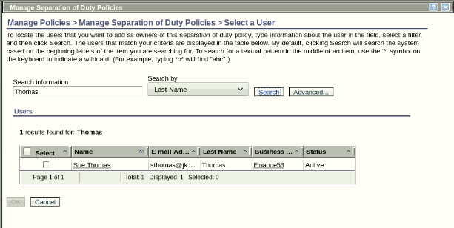 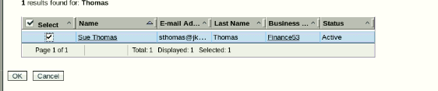
   7. Click Submit.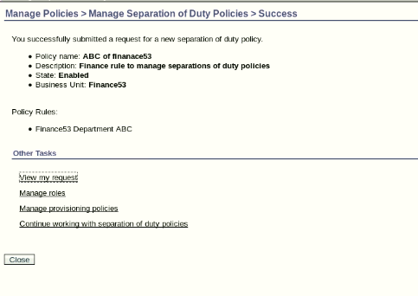
   8. Log out of the ISIM Console. Close Firefox.

1. Approving a separation of duty policy violation
   1. Restart Firefox. Open Firefox Enter the URL for the Identity Service Center (ISC) in Firefox: https://isim.test:9443/itim/ui/Login.jsp or click the bookmark (ISIM ISC)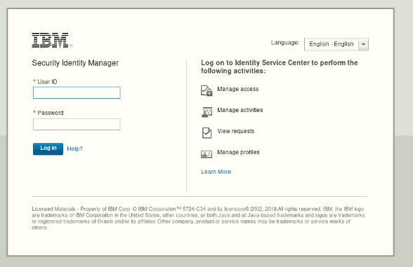
   2. Log on as Alice Smyth (asmyth) with password P@ssw0rd.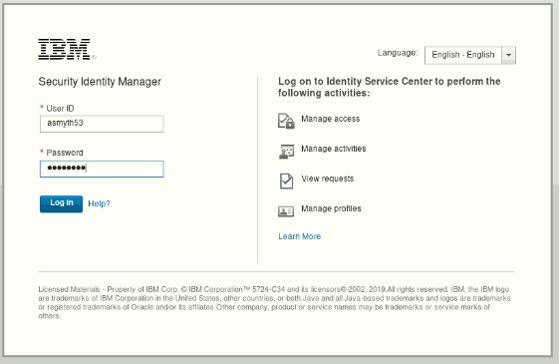 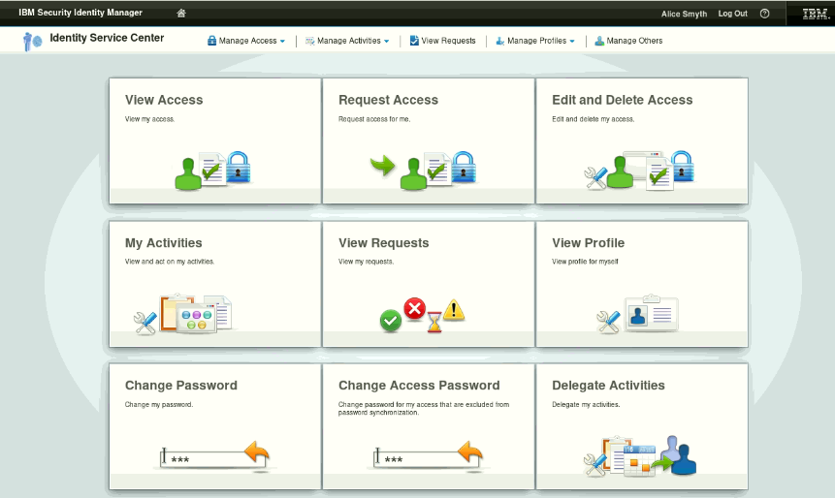
   3. Click Request Access to request access to the Asset Handling and Disposition role by Clicking the role and Click Next. Provide justification – Required for JKE Finance53 and Click Submit.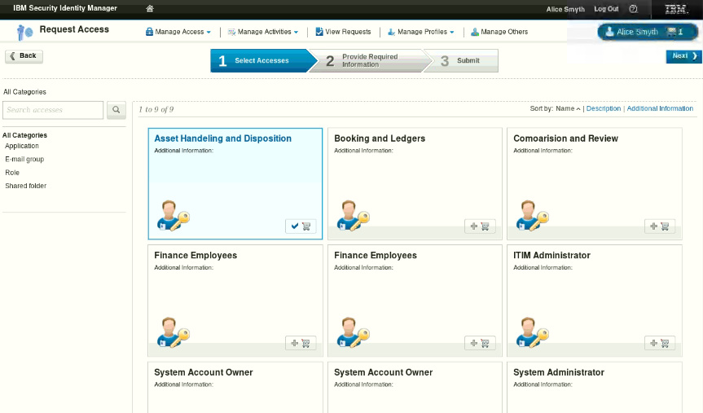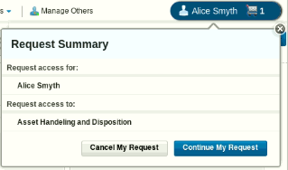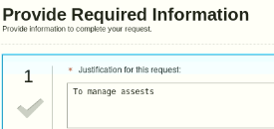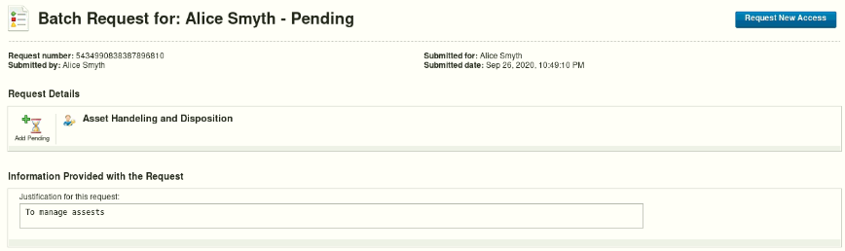
   4. Click on Request New Access, Request access to the Booking and Ledgers by Clicking the role. This action causes a violation for the Finance53 Department ABCs separation of duty policy. You can see the warning sign.Click the Yellow warning sign, see the details for violation.Click Continue My Request to request an exception. Provide justification – Required for JKE Finance and Click Submit. 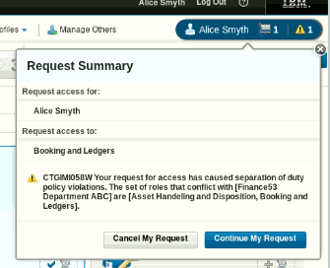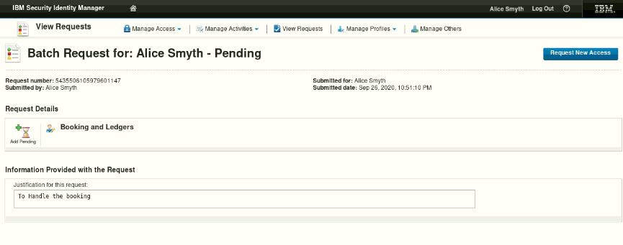
   5. Log out of the Identity Service Center.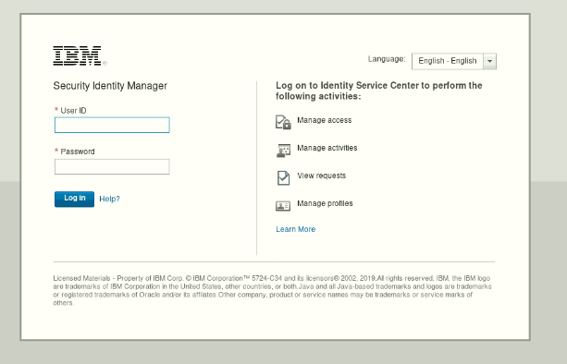
   6. Now, log in to the Identity Service Center as Sue Thomas and approve the separation of duty exception. Log back in as Sue Thomas (sthomas) with password P@ssw0rd.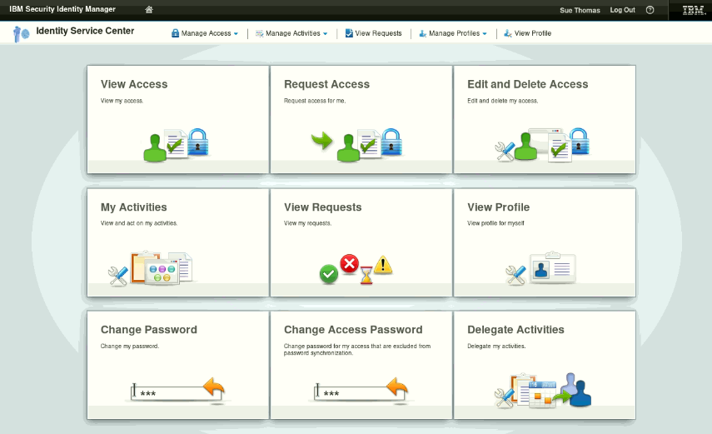
   7. Click on My Activities, on the right corner we can see Blue arrow, Click the arrow and we can see the policy violation details Provide Justification – Approved for Alice. Click Approve and Approve Alice’s separation of duty rule violation.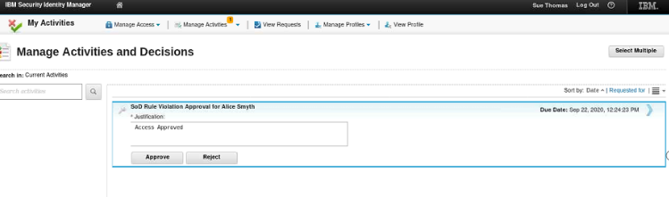
   8. Log out of the Self Service console. Close Firefox.